Interviews:

1. Was there anything confusing or unclear while using the website? Please explain.
2. What feature would you like to see added in a future update?
3. How well do you think the website communicates its message or mission?

A.A (Non-technical)

1. How some of the footer links didn’t direct me to the correct places.
2. Maybe booking some of the installations.
3. The website displays the idea of ‘green tech’ very well.

I.J (Non-technical)

1. The sign up and log in being a bit close, I was confused at first but then realised which one was which.
2. Some links to different energy sources
3. The layout communicates the message of green tech really clearly.

T.R (Technical)

1. The footer layout is not consistent throughout, e.g. placement of logo.
2. Allowing the user to log in and book a consultation or installation and then receive a confirmation message.
3. Websites display many images that resemble green tech.

Z.I (Technical)

1. Some of the direct easy links were not working which caused confusion.
2. An API that can show green energy usage in the community.
3. Good to an extent. The user interface displayed the green aspect very well but some of the functionality did not complete the mission.

P.O (Technical)

1. While using the website, some links did not work like ‘Schedule’ on the nav bar.
2. Letting the user purchase a product.
3. Shows all the three things Rolsa tech specialises in.

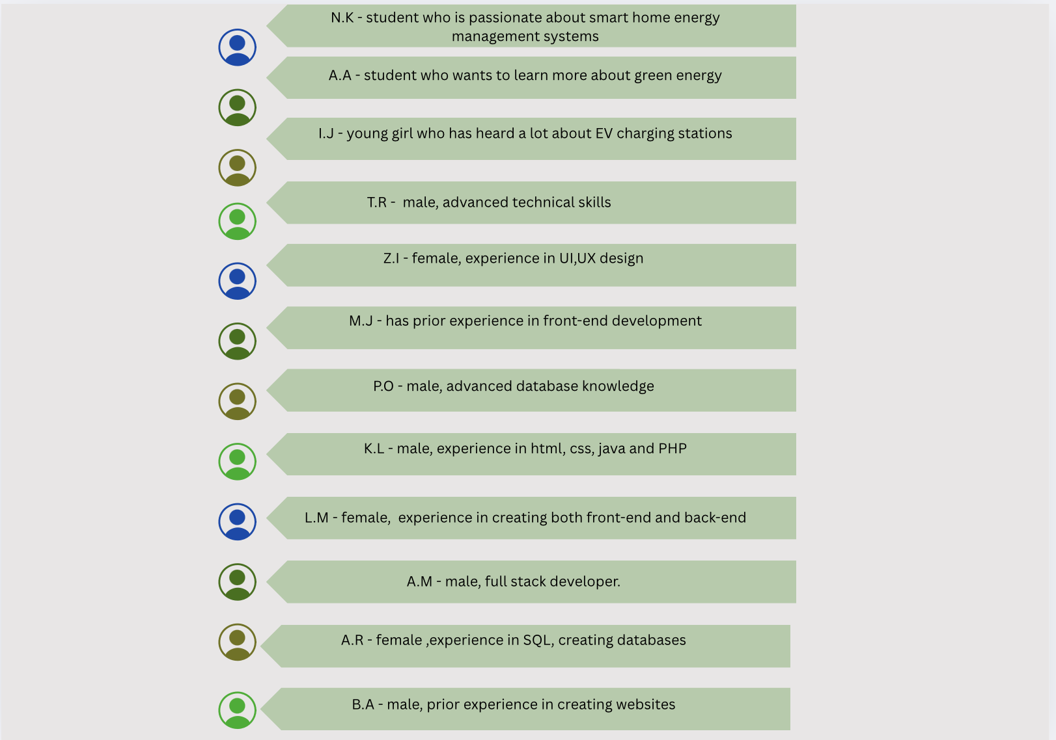

After inputting the screenshots of the feedback write this

Summary of feedback in detail

The result of rating the first impression is 4.25 out of 5 based on the feedback, where the highest score was 5 and the lowest was 4. I personally agree with this result as I believe the website successfully conveys the visual theme of green technology. The colour palette and layout give users a strong indication of the site's purpose, especially in promoting energy efficiency and smart systems. However, I also understand that there’s still room for development to improve accessibility and user engagement for a wider range of people, especially those less familiar with green tech.

One of the most common points raised in the feedback was around the booking system, which several users mentioned as a weak area. I’m aware of this issue and acknowledge that although I dedicated a good amount of time to building the front end, I did not prioritise the backend as much as I should have. The booking system, as it stands, lacks functionality and has caused confusion among users. If I had allocated more time to backend development, features like confirmation messages or error handling could have been implemented to give users a more complete experience. This is something I will definitely improve in future iterations.

Navigation

In the feedback form, I have asked testers if the nav bar was intuitive, clear and easy to navigate to which majority of the testers responded positively.

Here is a pie chart to support my conclusion:

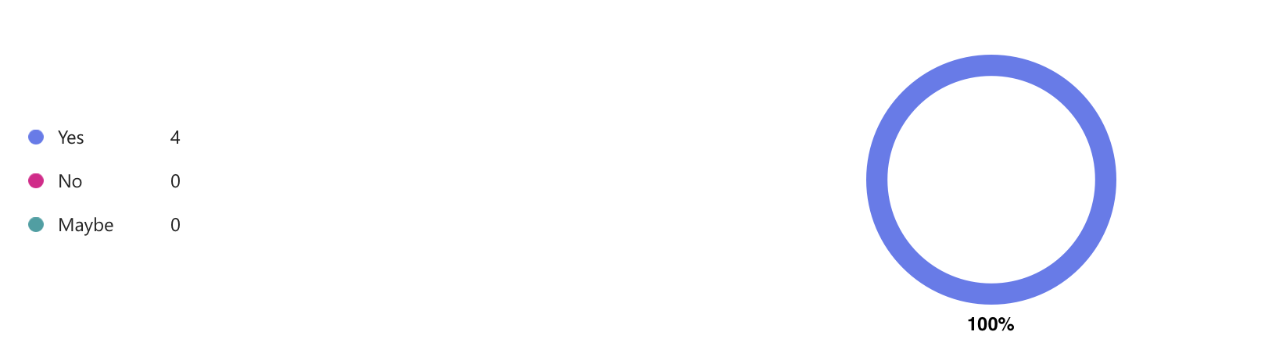

The other questions I asked:

Is the navigation bar easy to find and use? What would you rate the navigation bar and logo?

I asked these questions to see how easily users can access my website. A good nav bar helps users move through RTs website smoothly and efficiently reducing bounce rate.

Answers I received were:

*“The navigation bar is easy to find and easy to read so it makes it quick when on your website”*

“*Yes, it is clear and structured.”*

*“Yes, I think that it is very helpful”*

However:

*“make it slightly bigger”*

Which is understandable and will take this into account for future development.

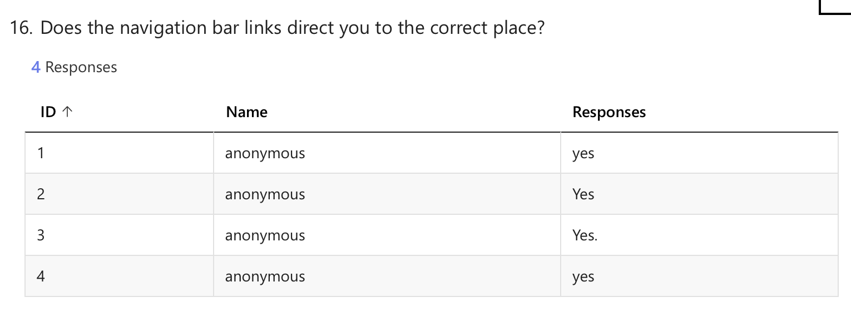

Homepage:

When designing the homepage, a lot of aspects were taken into consideration such as the colour scheme. In my opinion, the colour scheme was appropriate for Rolsa tech, it resembled the company's values clearly whilst also engaging the user effectively.

Therefore, I have asked these questions:

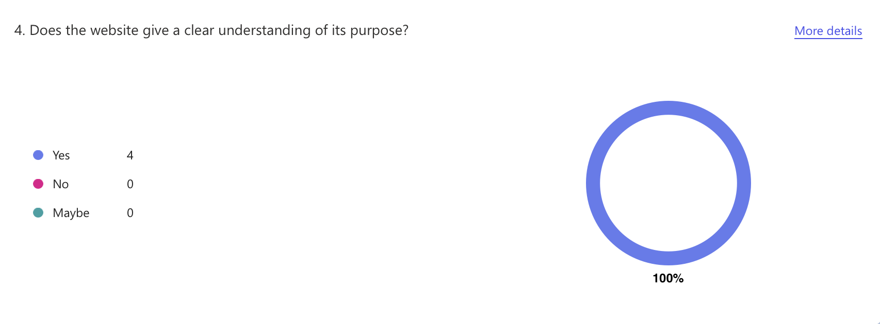

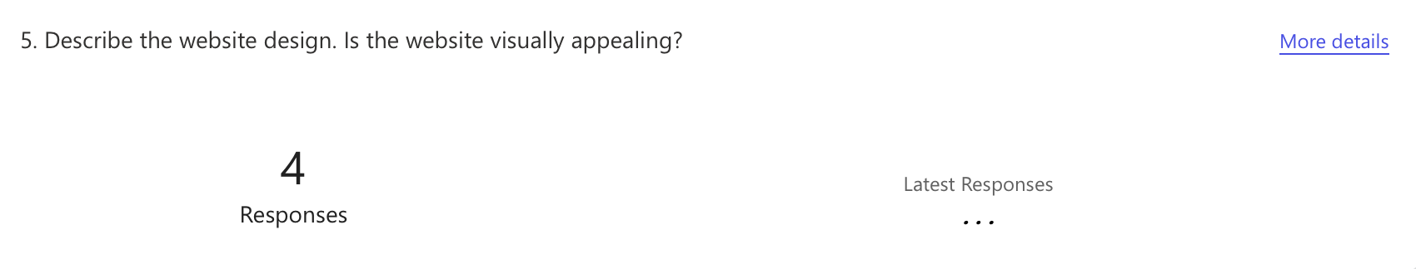

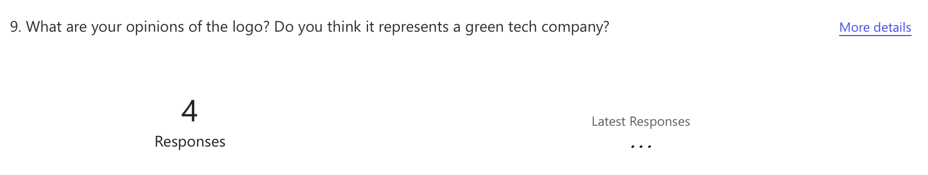

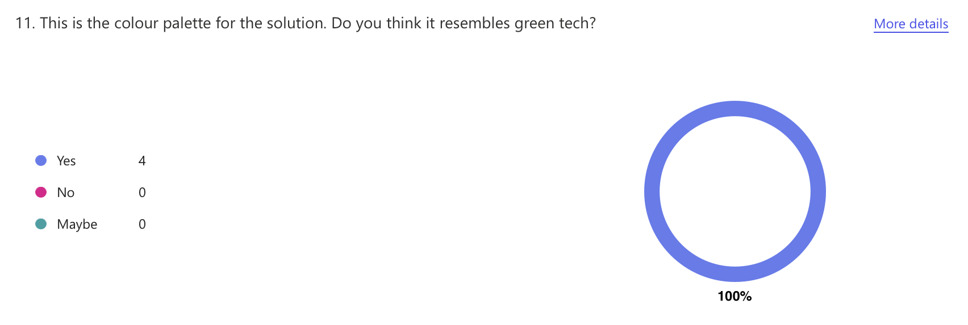

Testers have answered positively, which means the colour scheme should be kept when further developing this project.

On the homepage, there was also buttons which could hover; therefore, I asked the users the following questions:

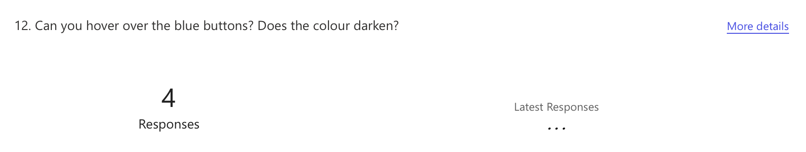

In which all the users responded ‘Yes’.

Overall, the main goal of the homepage was to display the message of green tech clearly, so I asked:

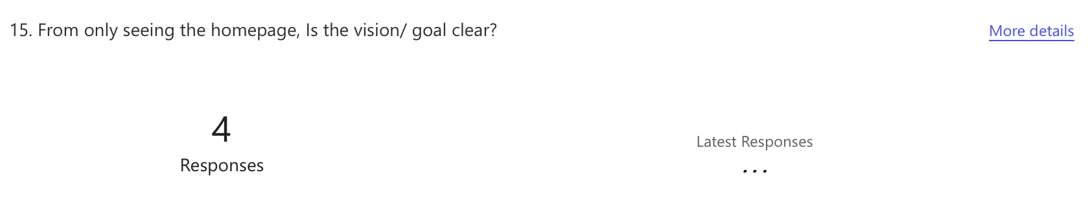

About us

I have asked users to test the about us page as it has buttons that direct users to what pages they click on. The majority had said that the information was ‘informative’ however some of the buttons do not work. For future development, I plan to create an alert button stating this does not work so users will not get confused or interrupt their process of using the website.

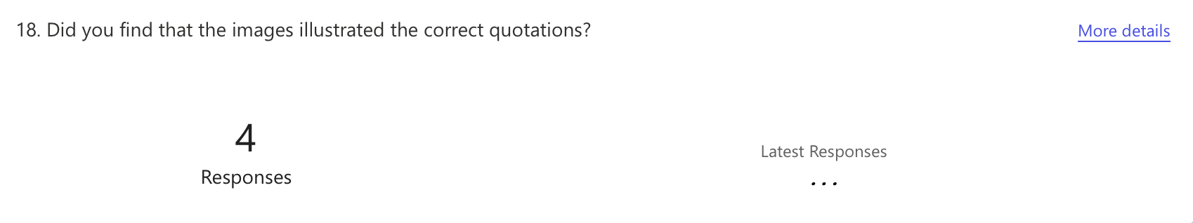

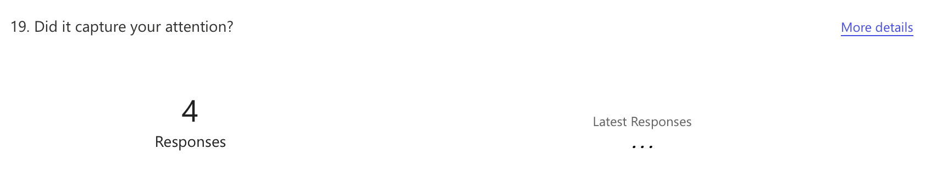

Users seem to enjoy the images and had said that it captured their attention which is good news to me.

From this feedback, I can consider that the user interface was a success and should be kept on the website. However, in my opinion, a lot of development could make the about us page much better like including an API that showcases the user’s local community electricity status.

Log in / Sign up page

I asked users to test the log in and sign-up system. There is an average rating of 4.50 which is more than understandable as in my opinion a lot of aspects of this page can be fixed. For example, making the sign up clearer than the log in form so users can differentiate it with ease

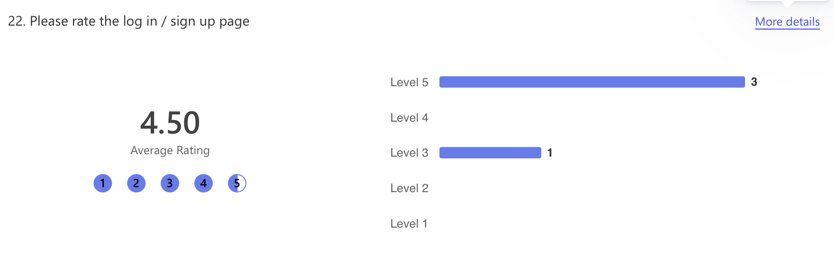

There were also social media icons that allow the user to log in another way however it cannot be carried out and will be fixed in further development. Therefore, I only asked the user if they could see it and the responses were:

*“Yes, I can see the icons below the log in button.”*

*“yes they are very clear to what they are meant to be”*

*“Yes, the social media icons are visible.”*

*“yes, i did see it, but the link didn't work”*

Unfortunately, users cannot book a consultation / installation as I prioritised the front-end instead of putting more time in the back-end database. Users can see the schedule page, however, they cannot actually book anything. I understand I should have made a pop up to let the user know that this is currently under development.

Therefore, I have asked the following:

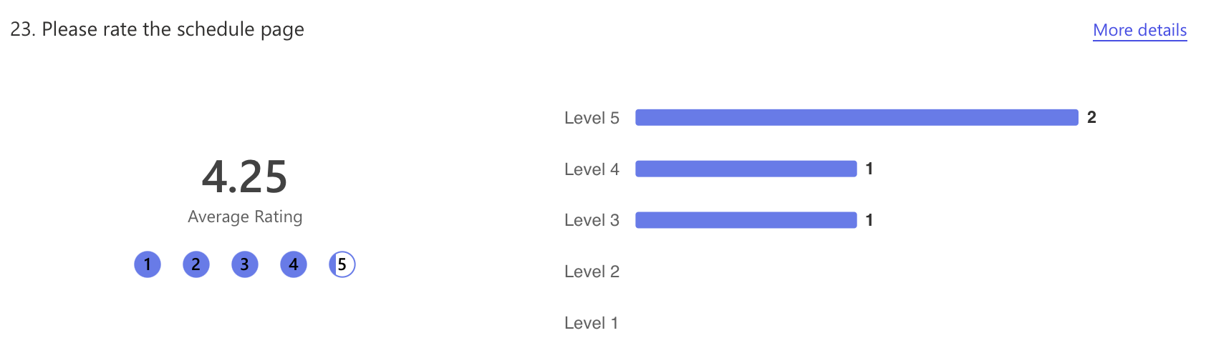

Carbon Calculator

I asked users to test the accuracy of the calculation and if it output the correct answer. Also, if the output of the answer was visible.

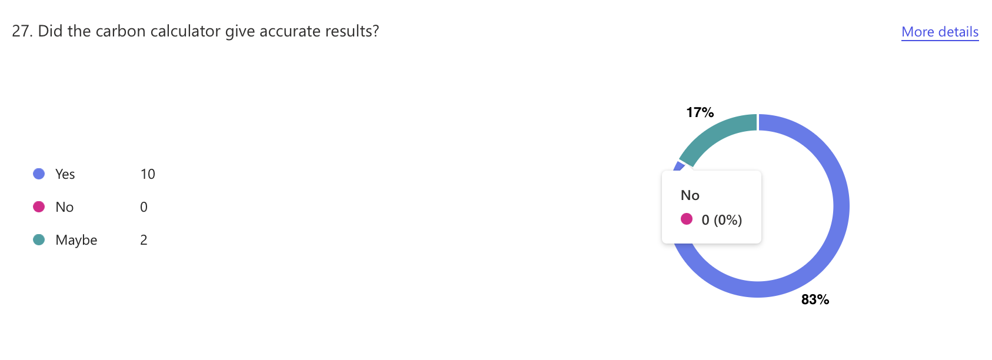

From this, we can gather that the calculations gave the correct outputs making users satisfied.

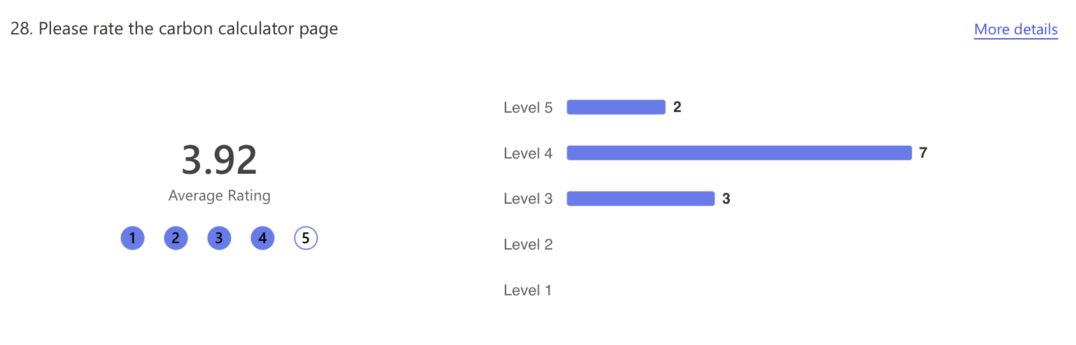

We gathered an average rating of 3.92, which in my opinion was kind, as a lot of improvements could have been made to make this page more efficient and tailored to the user. For example, letting the user log in or sign up so their calculation can be saved, or they could compare the difference from last week's calculation. Furthermore, in future development, there could be different ways of visually showcasing this data such as using graphs or charts.

Energy page

This page displayed a lot of information for users to take in and understand. It also had a quick form at the bottom to allow the user to track their energy usage.

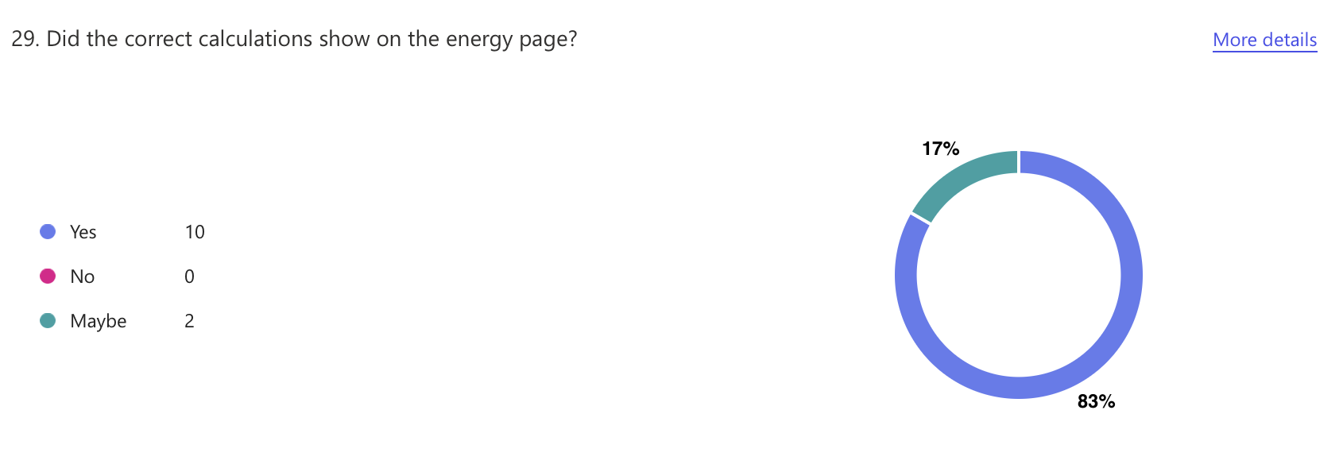

The overall average rating for this page was 4.00, with the majority rating it on a scale of 1-5 a 4. This positive feedback can ensure the information did not mislead users nor did the tracking energy form therefore this aspect can be kept whilst developing this project further. However, in my opinion, I would rate it a 3 as it is an average page that takes in the users input and calculates it. This could be done in many more efficient and time-saving ways like using an API. First, displaying the user’s current energy usage then letting users set usage goals or budgets, secondly showing savings or comparisons over time and finally promoting eco-friendly behaviors.

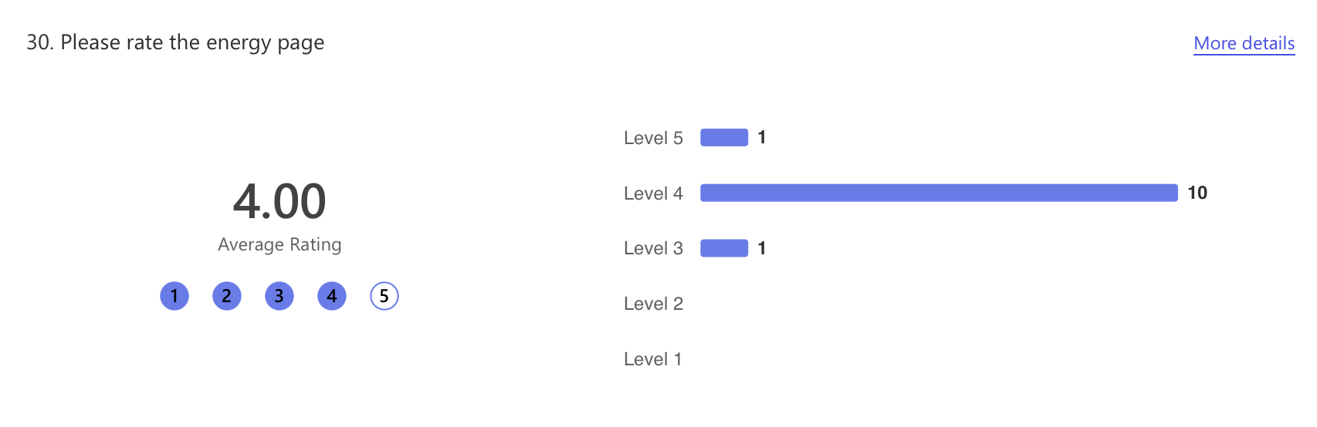

Pure technical questions

My form testers have more technical than non-technical users testing it, as I have realised my website's breaking point is the back-end. Therefore, needing more feedback from technical users.